University of Puerto Rico

Mayaguez Campus

INEL4206 - Microprocessors 1

Prof. Luis B. Roa

Is the A/C on?

Luis A. Santiago

Mark A. Alvarez

Ramón J. Rosario Recci

**LOGIC VIEW**:

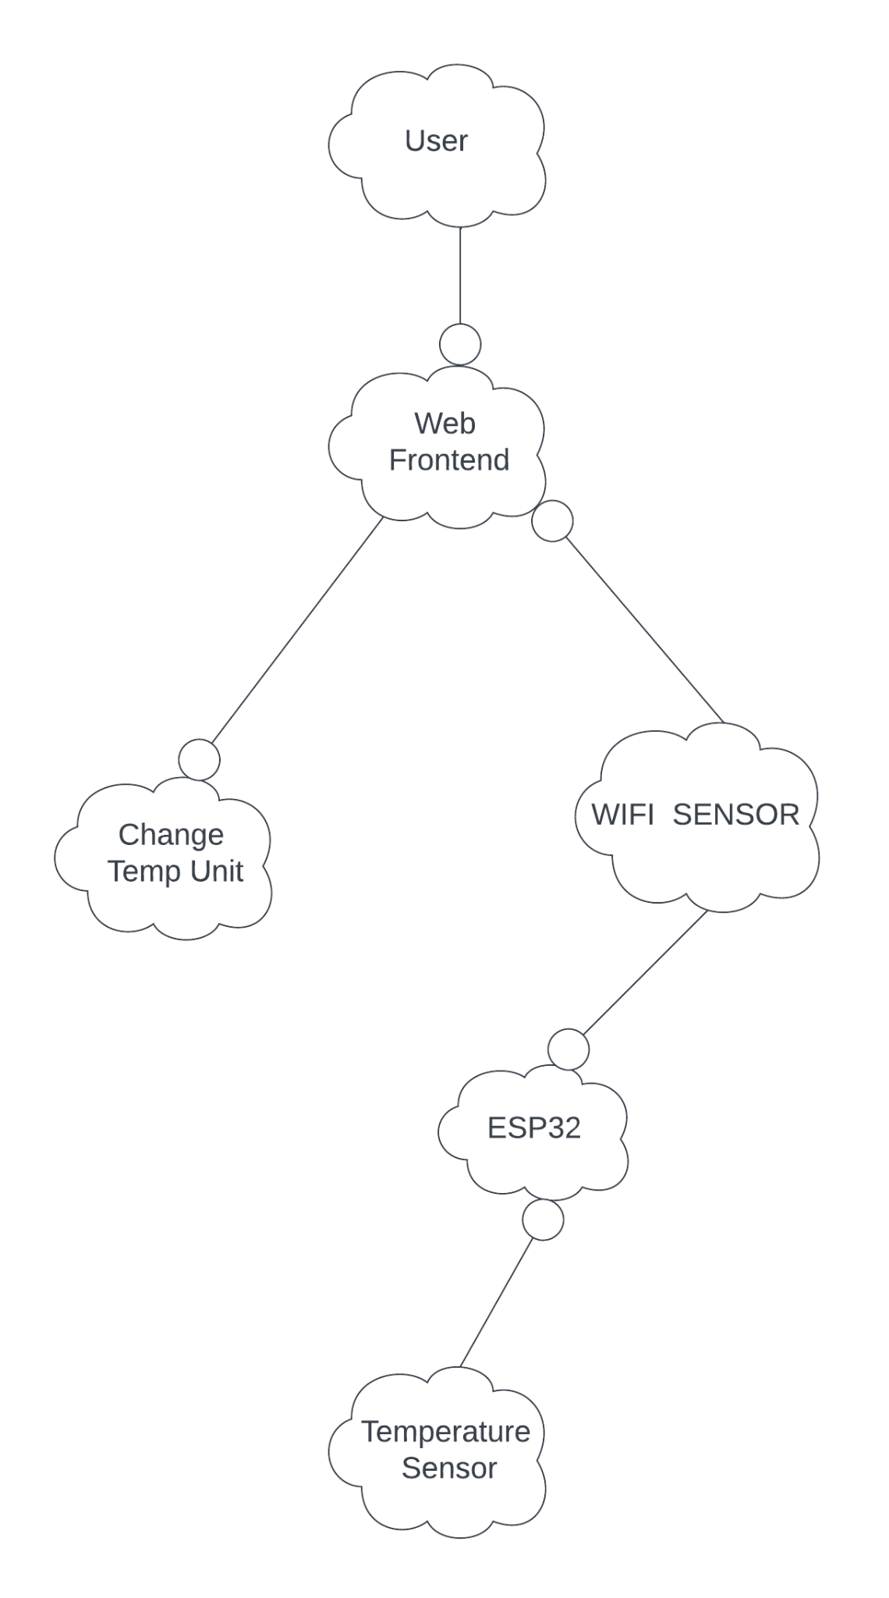

**PROCESS VIEW:**

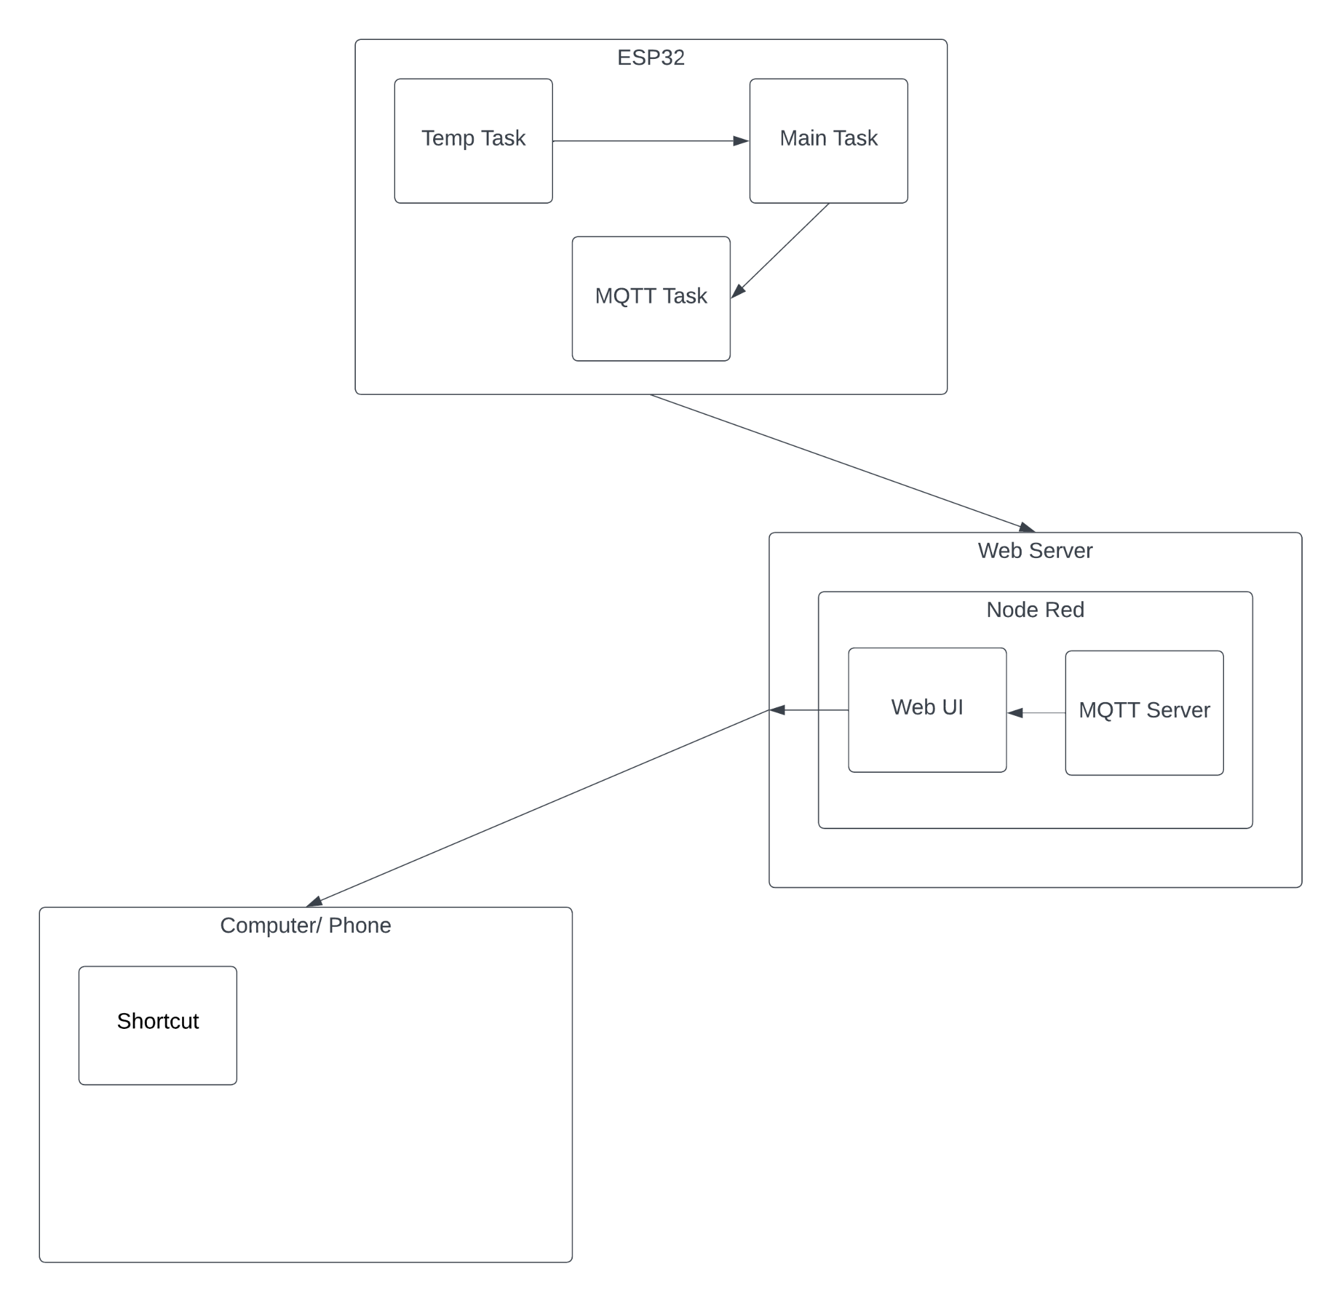

**DEVELOPMENT VIEW:**

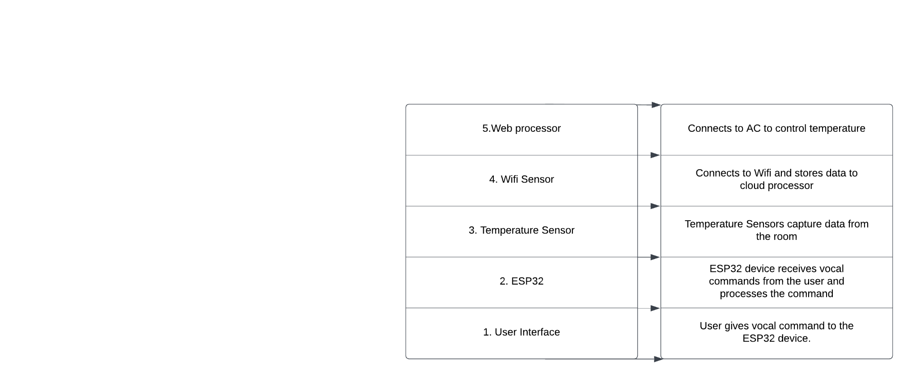

**PHYSICAL VIEW:**

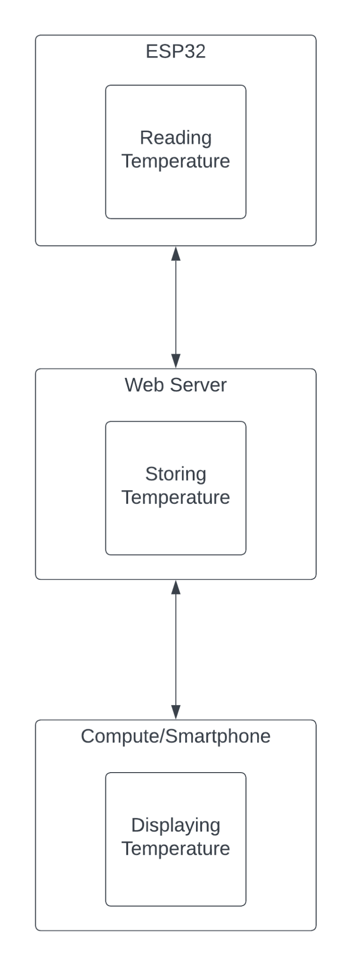

**SCENARIOS:**

